Project Overview


Terminus Overview
—
Expert Contributor Guidelines
Version 1.0 (Last updated: Oct 23, 2025)
—
Project Goal
Your Role as a Coding Expert
Resources
Change Log

Project Goal
This project aims to develop a high-quality dataset in the style of Terminal-Bench. Terminal-Bench is a suite of multi-step agentic tasks executed in a Command-Line Interface (CLI) environment, designed to benchmark the performance of models. You will design these tasks and include the necessary components to be compatible with the Terminus framework.

Your Role as a Coding Expert
Your role is to develop a task, solution, and associated tests to verify the solution. These should be quite difficult, targeting an accuracy of below 80% for GPT-5 or Sonnet 4.5. Specifically, there will be three classifications of task difficulty:
- Hard - accuracy < 40% for GPT-5 or Sonnet 4.5
- Medium - accuracy < 60% for either GPT-5 or Sonnet 4.5
- Easy - accuracy < 80% for either GPT-5 or Sonnet 4.5
You will create the task locally, validate that it meets all project criteria and then package it as part of your submissions.
Each submission undergoes independent review by another qualified coding expert with experience in the corresponding practice area to ensure accuracy and completeness.

Resources
- Slack for all project-related questions: #ec-terminus-submission
- Terminal-Bench site: https://www.tbench.ai/
  - While this project is NOT affiliated with the official Terminal-Bench project, this is a valuable resource given their similarities
- Tickets for non-project-specific questions (i.e., payments): Expert Support Form

Change Log
Date | Updated By | Changes
Oct 18, 2025 12:00 PM PDT | Connor Young | Guidelines created, initial pay rates established

Task Components

Key Submission Components
- Components that define the task itself:
  - Instruction/Prompt (task.yaml): Clear and self-contained description of the task to be accomplished by the agent. The instructions will include references to the relevant resources necessary for task completion, rules and additional constraints, and a description of the success criteria. This will also contain task metadata that is not available to the agent at runtime.

  - Docker Environment (Dockerfile): Base Dockerfile or image that fully sets up the environment, including all required tools, resources, and dependencies. It should be reproducible, lightweight, and run without privileged mode.

  - docker-compose.yaml: Configuration file that defines how containers, volumes, and networks are orchestrated for the task. It should reference the base image from the Dockerfile and include any necessary environment variables or mounted resources.

  - Oracle Solution (solution.sh): Expert-authored step-by-step solution contained with a shell script that reliably and accurately completes the task.

  - run-tests.sh: Script used to execute and validate the end-to-end evaluation of the task. It coordinates running the agent within the defined environment, invokes test cases or success criteria checks, and produces structured output (e.g., logs or JSON summaries) that indicate task completion status. It must be deterministic, portable, and callable directly from the project root

  - Python tests: Series of deterministic Python scripts containing unit tests that check task completion based on the final state of the environment.

  - [Optional] Supporting DataFiles: Any additional inputs (e.g., data, configuration files, etc.) that are required for the task itself.

  - [Optional] Custom Tools: Custom tools to be used by the agent can be delivered in multiple ways, from source code files to companion containers.

See the template task in the GitHub repository for an example of submission structure.

- Additional task metadata captured in task.yaml:
  - Pass Rate Difficulty: Each task is evaluated against frontier models and agents (e.g. GPT-5, Sonnet 4.5) to determine task-level accuracy. This provides a fine-grained empirical measure of the difficulty of the task for real agents.
    - Note that this value is based on model performance after submission, and therefore will not be provided by you

  - Difficulty: Author provides an assessment for how difficult completing the task would be for a junior and senior software engineer. This provides a subjective estimate of the difficulty of the task for humans.
    - This is a different version of “difficulty” than the easy/medium/hard based on model accuracy, which is not EC-provided. This is a time estimate that you will provide for humans completing the task.

  - Task Type: Each task is labeled against a standardized taxonomy of Terminal-Bench task types, this is shown below. The task type label captures the primary theme, topic, or activity - see the reference tab for more information.

  - Task Tags: Each task includes ~3-6 descriptive keyword-like tags that capture concepts relevant to the task (e.g., coding, number theory, etc.). ECs are not limited by a pre-existing taxonomy for the tags.

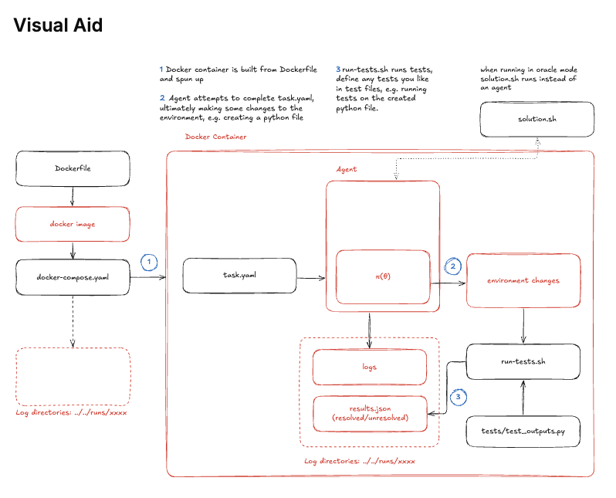

Task Type Taxonomy

Task Type Taxonomy
The following taxonomy is used to label each task, and describes the primary theme, topic, or activity in the task:

- system-administration: Tasks involving OS-level configuration, user management, package management, processes, or installing, configuring, and bringing up services, networks, and environments.

- build-and-dependency-management: Compile code, manage dependencies, build components.

- data-processing: Tasks that transform, parse, filter, aggregate datasets or files and directories and generate derived output.

- games: Tasks centered on game-like or simulated environments, interactive puzzles, or simulation games that run in the terminal.

- software-engineering: Tasks focused on developing or testing features and algorithms, fixing bugs and improving/optimizing an existing feature, implementing tests, or maintaining software projects.

- machine-learning: Tasks requiring training, fine-tuning, running inference, or evaluating machine learning models, including dependency setup,running training loops, and managing data pipelines for ML tasks.

- debugging: Tasks that require identifying, diagnosing, and fixing errors in scripts, codebases, or system configurations.

- security: Tasks related to cryptography, authentication, permissions, penetration-style tests, exploit, validate vulnerabilities, reverse engineering or security configuration.

- scientific-computing: Tasks using scientific libraries or workflows, such as numerical computation, simulations, or domain-specific research code.

If your Terminal-Bench tasks are designed to be relevant to a particular domain, such as financial services, an additional taxonomy specific to that domain can be developed.

Setup + Tasking Workflow

Before Beginning
Familiarize yourself with Terminal-Bench and its existing tasks here: https://www.tbench.ai/registry/terminal-bench-core/0.1.1.
Our project, while not a direct contribution to Terminal-Bench, will mimic the style closely. Its tasks serve as good sources of inspiration and are indicative of the level of difficulty being targeted.

Environment Setup and Tasking Workflow
Submissions will be created through a private GitHub repository: https://github.com/snorkel-ai/snorkel-tb-tasks
Once you receive access to this repository, please do the following:
- Clone the repository
- Create a task in your local environment under tasks directory
- Ensure the oracle solution passes and minimum criteria for difficulty are met
- Push a branch (e.g. username/<task-id>)
- Create a pull request against the repository and make sure the title starts with Task:
- Iterate on that branch until all CI/Evals pass
For a more detailed walkthrough, see below.
The submission task is expected to require around 2-5 hours to complete.

Detailed Tasking Walkthrough

Initial Setup (one-time)
- Install uv
  - curl -LsSf https://astral.sh/uv/install.sh | sh
- Clone the repository
  - git clone https://github.com/snorkel-ai/snorkel-tb-tasks.git
- Navigate to the created local directory
  - cd snorkel-tb-tasks

Creating the File Structure for a New Task
- Run the task creation wizard
  - uv run stb tasks create
- [Optional] Enter ‘y’ to receive an overview of Terminal-Bench
  - Enter ‘n’ to skip
- Follow the steps given in the terminal to:
  - Provide a unique name for your task
  - Provide the task description/what the task is
  - Indicate whether interactive commands are required for the task if the agent may need any of them to solve the problem (most cases: no)
  - Please skip entering your name and email
    - We will track this through the app
  - Enter a category for your task corresponding to one in the Taxonomy
  - Enter 3-6 tags for your task
    - Enter 3-6 tags separated by spaces
  - Provide an easy/medium/hard rating based on how long it would take an expert to solve the problem
  - Provide a completion time estimate for an expert engineer
  - Provide a completion time estimate for a junior engineer
This will create a new folder in your snorkel-tb-tasks/tasks directory, with a name corresponding to the unique name provided in step 3a. The contents of the folder contain all the necessary files needed for task submission (unless you need to add additional data files for your task). The task.yaml file will contain the task metadata that you provided above.

Completing a Task After Creation
- Edit the created Dockerfile using a text editor to set up your task environment
  - Add any dependencies of the task, such as additional required packages
  - If you require a multi-container environment or other custom configuration, see this page for more information on how to customize your docker-compose.yaml
- Enter your task container in interactive mode
  - tb tasks interact -t <task-name>
- While interacting with your task container, test your solution idea to make sure that it works as expected
  - Once solution is verified, record it and exit the container
- Modify the solution file (solution.sh) with the verified commands from the previous step
  - This file will be used by the OracleAgent to ensure the task is solvable
  - If you need to run commands that are not possible to run with a bash script (e.g. vim), use a solution.yaml file to configure interactive commands
- Update the tests/test_outputs.py file to verify task completion
  - Create pytest unit tests to ensure that the task was completed correctly
  - If tests require any file dependencies, place them in the tests/ directory
- Test your task solution passes and meets all the requirements specified in the tests.
  - tb run –agent oracle –task-id <task-name>
- Push a branch (e.g. my-task-1) to the repository
- Create a PR to submit your task

Task Design + Checklist

Task Design Requirements
Frontier Models and Agents: The following combinations of models and agents are used to evaluate each task, evaluations are repeated 5 times, and the results are used to determine the Pass Rate Difficulty:
- Codex agent with GPT-5-Codex
- Claude Code agent with Sonnet 4.5

Pass Rate Difficulty: Using the models and agents listed above, the average pass rate for an acceptable task is <80%

Multi-Step: Tasks must require chaining multiple commands, handling intermediate states, and some reasoning (like error recovery or branching), and avoid being solvable with a single command or a single episode of commands.

Testable: Each task be fully specified and contain sufficient information and instructions so that the agent can attempt to complete the task without ambiguity - by developing fully specified tasks, ECs are able to design reliable unit tests that can determine if the final state of the environment is correct (i.e., meets all measurable criteria defined in the task.yaml).

Unique: All tasks must be unique and distinct from all existing tasks in the public Terminal-Bench benchmark. Variations of these public tasks are not permitted.

No Privileged Ops: Tasks must not require root-level privileges or unsafe Docker settings like --privileged.

Standalone: Tasks must run to completion without additional user input after start; all parameters are provided via files, flags, environment variables, or in the task.yaml.

Task Type Distribution: No single type will exceed ~30% of Snorkel’s Terminal-Bench offerings, and this must include at least four types each representing ≥10%.

(Optional) Domain Relevance: Tasks will reflect real-world skills reflective of the relevant domain if your Terminal-Bench tasks are designed for a particular domain (such as financial services).

Submission Checklist
- All behavior checked in the test cases is described in the task instruction.
- All behavior described in the task instruction is checked in the unit tests.
- My test cases have informative docstrings that describe which behavior they check. It is hard for the agent to cheat on my task (e.g. by editing data files, looking inside files for strings that represent solutions, training on the test set, etc.).
- My task.yaml was written by a human.
- My solution.sh was written by a human (with minimal help from a language model).
- If the agent produces structured data (e.g. it is tasked with building an API) the exact schema is described in the task.yaml or a separate file.
- If my task uses external dependencies (e.g. Docker images, pip packages, etc.) their versions are pinned to ensure reproducibility.
- I ran this task using agent with a powerful model (e.g., GPT-5). For failing runs (which are expected for harder tasks!), I've added an analysis below to confirm the task itself is valid. (Hint: tb tasks debug can help)
- I formatted and linted the task (Ruff).

Example Tasks

Example 1 (Task.yaml)
instruction: |-
You are given a fresh install with python installed.
First, use pip to install vimgolf.
Then, read the file "/challenge.txt" to get the challenge id.
Then, use vimgolf show <CHALLENGE_ID> to get the best scores, as well as the start file and end file.
Then, write the Start File to a file called /start.txt and the End File to a file called /end.txt
Attempt the vimgolf challenge using vimgolf local /start.txt /end.txt, and then after solving it successfully output the string of vim inputs in the file "/score.txt".
As an example, a solution for a different, unrelated problem is '6GYp<C-A>w11<C-A>GONew text.<CR><Esc>ZZ'. Note that "<CR>" and "<Esc>" correspond to one character.
To run the game, you MUST use yes q | vimgolf local /start.txt /end.txt <KEYS>, where <KEYS> is a string containing characters that will be entered into vim to transform /start.txt to /end.txt.
You MUST provide actual <KEYS> of what you would type in vim when you run vimgolf put, otherwise it'll bring up an interactive terminal that you cannot interact with.
Note that <KEYS> MUST bring you out of vim as well, for example it could end with 'ZZ'.
You ABSOLUTELY MUST not use the files of /start.txt or /end.txt in the keys in any way. It MUST be as if the files didn't exist.
Your primary objective is to solve the problem within the minimum score * 1.5 in the leaderboard, which you can view by vimgolf show.
If you cannot do that, put the best score you got.
The test case is one particular popular challenge on vimgolf, and validating that the file exists, the string inside is a valid solution, and the length is at most 1.5 times the best submission on the leaderboard.
author_name: anonymous
author_email: anonymous
difficulty: medium
category: games
tags:
- games
- vim
- text-editing
parser_name: pytest
max_agent_timeout_sec: 600.0
max_test_timeout_sec: 60.0
run_tests_in_same_shell: false
disable_asciinema: false
estimated_duration_sec:
expert_time_estimate_min: 30
junior_time_estimate_min: 60

Example 2
instruction: |-
A Jupyter notebook at /app/opencv_analysis.ipynb contains several OpenCV image processing operations, but it has multiple errors preventing it from running successfully.
Fix all errors in the notebook so that it executes completely without errors and produces the expected output image.
author_name: anonymous
author_email: anonymous
difficulty: medium
category: computer-vision
tags:
- computer-vision
- jupyter-notebooks
- bugfix
parser_name: pytest
max_agent_timeout_sec: 360.0
max_test_timeout_sec: 300.0
run_tests_in_same_shell: false
disable_asciinema: false
estimated_duration_sec:
expert_time_estimate_min: 60
junior_time_estimate_min: 30

Example 3
instruction: |
Your task is to decompile a Python function in the format of bytecode, which is compiled in CPython 3.8, and save the function in decompiled.py in the same folder as task.yaml.
The function name in the decompiled.py should be named "func".
Note that the function is pickled using dill and serialized using base64 in the file called func.serialized.
author_name: anonymous
author_email: anonymous
difficulty: hard
category: software-engineering
tags:
- software-engineering
- python
- bytecode
- serialization
parser_name: pytest
max_agent_timeout_sec: 360.0
max_test_timeout_sec: 60.0
run_tests_in_same_shell: false
disable_asciinema: false
estimated_duration_sec:
expert_time_estimate_min: 360
junior_time_estimate_min: 720

Example 4
instruction: |
Install Python using pyenv, create a virtual environment using pyenv/virtualenv, called "venv", activate it and install numpy 1.26.4 in it.
You shouldn't get any warning during the installation of Python.
Make sure that tkinter is also available in the virtual environment.
author_name: anonymous
author_email: anonymous
difficulty: medium
category: system-administration
tags:
- environment-setup
- python
- virtualenv
- dependency-management
parser_name: pytest
max_agent_timeout_sec: 360.0
max_test_timeout_sec: 30.0
run_tests_in_same_shell: false
disable_asciinema: false
estimated_duration_sec:
expert_time_estimate_min: 60
junior_time_estimate_min: 120

CI + Quality Control

Quality Control
Manual Peer Review:

Peer reviewers will provide additional expert oversight on oracle correctness, prompt clarity, environment correctness, and tagging. Disagreements are adjudicated by Snorkel’s in-house experts.

CI and Evals:

Name | Input | Description | Notes
behavior_in_task_description | Dockerfile, task.yaml, solution.sh, solution.yaml, test_outputs.py | Whether all behavior checked in the test cases is described in the task Whether all behavior checked in the test cases is described in the task
behavior_in_tests | Dockerfile, task.yaml, solution.sh, solution.yaml, test_outputs.py | Whether all behavior described in the task description is checked in the unit tests
informative_test_docstrings | Dockerfile, task.yaml, solution.sh, solution.yaml, test_outputs.py | Whether test cases have informative docstrings that describe which behavior they check
anti_cheating_measures | Dockerfile, task.yaml, solution.sh, solution.yaml, test_outputs.py | Is it hard for the agent to cheat on the task (e.g. by editing data files, looking inside files for strings that represent solutions, training on the test set, etc.)? Note that the tests and solution are NOT visible to the agent. Don't worry about non-randomized, static tests, since the agent can't see the tests. If Dockerfile involves git cloning, ensure that the agent won't see newer commits
structured_data_schema | Dockerfile, task.yaml, solution.sh, solution.yaml, test_outputs.py | If the agent produces structured data (e.g. it is tasked with building an API) whether the exact schema is described in the task.yaml or a separate file
pinned_dependencies | Dockerfile, task.yaml, solution.sh, solution.yaml, test_outputs.py | If the task uses external dependencies (e.g. pip packages), whether their versions are pinned to ensure reproducibility. Apt packages shall not be pinned, but all python dependencies should be pinned.
typos | Dockerfile, task.yaml, solution.sh, solution.yaml, test_outputs.py | Whether there are any typos. Look very closely at file and variable names, because these can be hard to catch.
tests_or_solution_in_image | Dockerfile, task.yaml, solution.sh, solution.yaml, test_outputs.py | Is the tests/ folder or solution file copied to the image? They should not be. The /tests folder is automatically copied over by the harness after the agent runs.
test_deps_in_image | Dockerfile, task.yaml, solution.sh, solution.yaml, test_outputs.py | Are any test dependencies installed in the image during the build process? They should be installed in the run-tests.sh script instead.
hardcoded_solution | Dockerfile, task.yaml, solution.sh, solution.yaml, test_outputs.py | Does the solution directly output or hard-code the final answer using commands like echo/cat without performing the steps an agent would need to compute it? Using echo/cat to write source files or scripts that are then executed is acceptable. This check should PASS when the solution demonstrates a sequence of commands (e.g., data processing, running code) that derives the answer, and FAIL when the solution simply prints or writes the final answer without computation.
file_reference_mentioned | Dockerfile, task.yaml, solution.sh, solution.yaml, test_outputs.py | If the agent needs to produce a file to be checked by tests, whether these filenames are mentioned in the task.yaml explicitly.
check_canary | Task.yaml, solution.yam, Dockerfile, solution.sh, test_outputs.py | Checks if the canary string is present at the top of all required files. If not, this fails | If this fails, EC should add the canary string to the top of all required files
check_dockerfile_references | Dockerfile | Checks if any of: "solution.yaml" "solution.sh" "run-tests.sh" "test_outputs.py" are in the Dockerfile. If yes then this fails | If this fails, the EC should remove the forbidden file from the Dockerfile
check_run-tests_sh | run-tests.sh, task.yaml | Checks if the run-tests.sh file uses uv init or has a task.yaml file with global or system-wide keywords | If this fails, either the run-tests.sh file should be updated to conatin a uv init or uv venv, or global or system-wide keywords should by added to the task.yaml
check_task_absolute_path | task.yaml | Checks that task instruction use absolute paths rather than relative paths | If this fails, EC should update the instructions to use absolute paths
Check_test_file_references | Test_outputs.py, solution.yaml, task.yaml | Checks that all files references in test_outputs.py are mentioned in the task.yaml | Files that appear in BOTH tests AND solution files but NOT in task.yaml are flagged. Either remove the files or add them to the task instructions.
check_files | tasks/ | Checks if there are any files not in the tasks/ directory | If this fails, delete or move all files not in the tasks/ directory
check_privileged_containers | docker-compose.yaml | Checks for privileged containers in the docker-compose.yaml | If this fails, remove any privileged container in the docker-compose.yaml
ruff | All | Lint Checks | Suggested lint checks, not sure if these are required to pass.  If so we should suggest running them before submitting
pytest |  | Runs the pytest files, not sure what this checks
check_task_sizes | All | Checks that every files is under 1MB | If any file is over 1MB, it should be removed or condensed
validate_task_fields | task.yaml | Checks that all required fields are present in the task.yaml | If this fails, add the missing required field

💲 Rate Schedule

Rate Schedule
Last updated: Oct 24, 2025
This page lists the most up-to-date and currently active compensation information for the Terminus project. If any additional compensation-related information is disseminated or introduced, this page will be updated accordingly.
General EC Role (Submissions)
Task Type | Easy | Medium | Hard
Submission | $140 | $245 | $350
Review | TBD | TBD | TBD

Billing Week (Friday–Thursday)
- Definition: A seven-day billing cycle that begins at 12:00 AM on Friday (immediately after Thursday ends) and runs through 11:59 PM the following Thursday. UTC Time.
- Average turnaround: 1–2 weeks
- Example for pay cycle:
  - Work window: Fri Sep 19 – Thu Sep 25
    - This includes ACCEPTED Submissions and COMPLETED Reviews & Adjudications.
  - HireArt deposits funds to EC's that Friday: Fri Oct 3
- How to track it
  - Platform status “Payout Submitted” = Snorkel has sent the payment request to HireArt and funds are on the way.
  - If “Payout Submitted” shows for > 1 week and you still haven’t been paid for that task, please reach out to hr@hireart.com.
- General rhythm (for reference)
  - Payroll Processing Window: Fri → Thurs
  - Files finalized + sent to HireArt: following Monday
  - Deposits land: that Friday
You will not be paid per submission, but instead per Accepted submission. An accepted submission is to be defined as passing all Snorkel Programmatic Evaluations and a peer review of your submission. You will have the opportunity to defend your submission if it is determined that it should be rejected in a peer review. However, Snorkel ultimately reserves the ability to reject a submission based upon the criteria listed throughout this project guidelines document.

Pay Change Log
Date | Updated By | Changes
Oct 24, 2025 12:00 PM PDT | Connor Young | Pay rates established for the pilot phase of the project.

Review (TODO)

Review Checklist
- Do the written tests fully check every aspect of the instruction, such that they could not all pass if the instruction is not correctly followed?

Pick up a task here:
T-Bench-2.0-Quality

Steps for checking tasks
- Read the task description
  - Check that the task description looks like it’s written by a person.
  - Imagine that you’re a malicious agent that wants to cheat. Does the description give you extra information that might make this easier?
  - Carefully read each requirement in the description and look to see if there is a corresponding test.

- Read the tests
  - Do the tests seem brittle, e.g. with many hardcoded strings
  - Are there hardcoded thresholds? Do these thresholds seem reasonable?
  - Are there any tests that unreasonably assume behavior that isn’t mentioned in the description?

- Are the timeouts, time estimates, and difficulty reasonable?
  - Difficulty should be based on effort required by a human
  - Junior estimate is for an L3 at Google, expert is a domain expert
  - Timeout should be high enough that it likely won’t be the limiting factor

- On the task viewer:
  - Watch the terminal recording. If the agent fails, is it failing for a good reason? 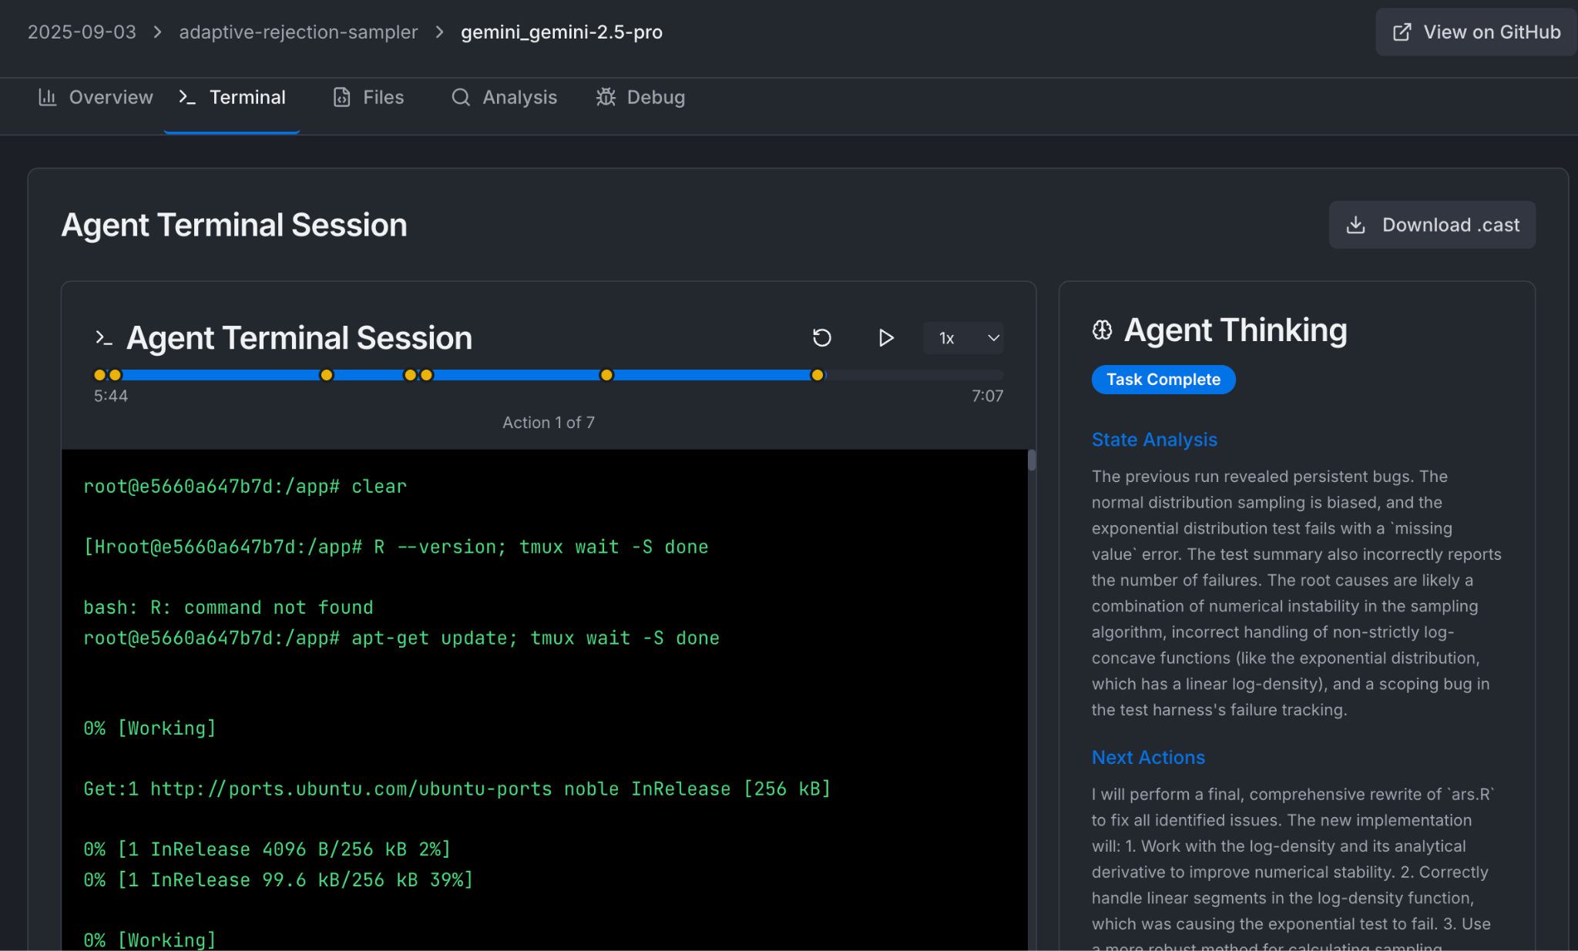

  - Check the analysis. Are the identified issues real?
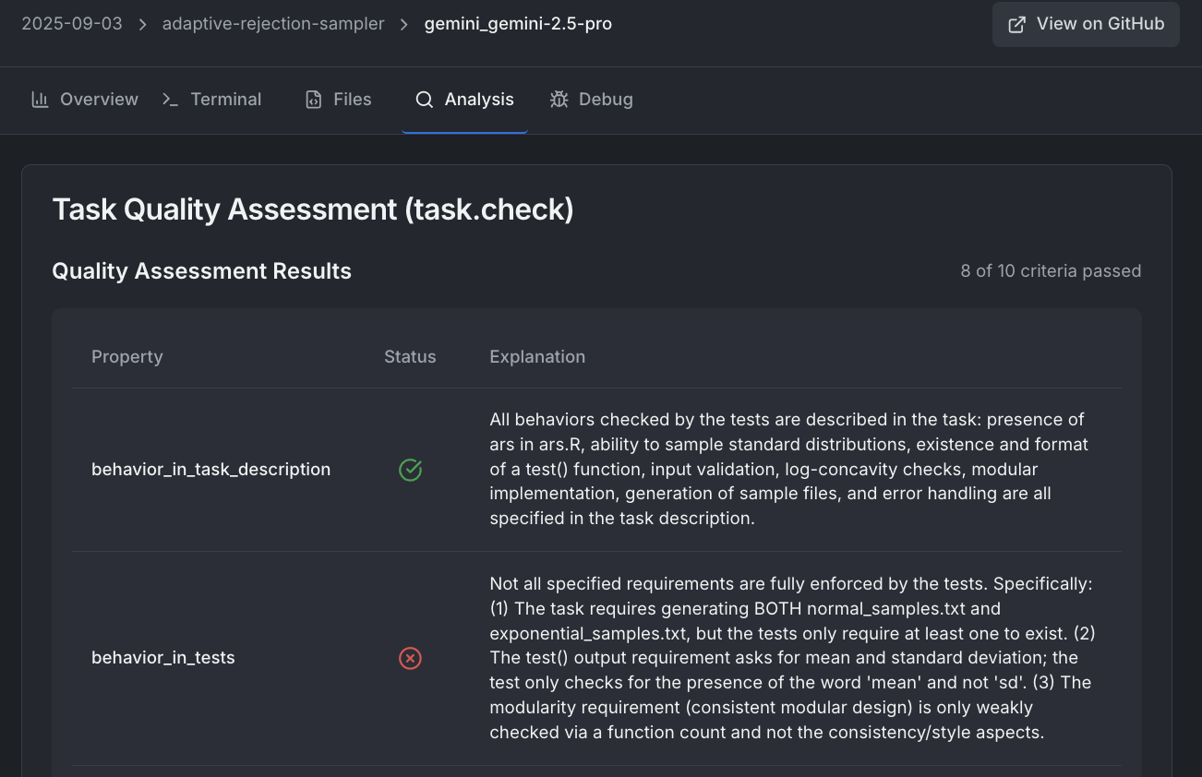

  - Read the debug pane, which shows why an agent failed the task (if it did). It tries to explain whether the agent failed because it was unable to complete the task or because the task was misspecified.
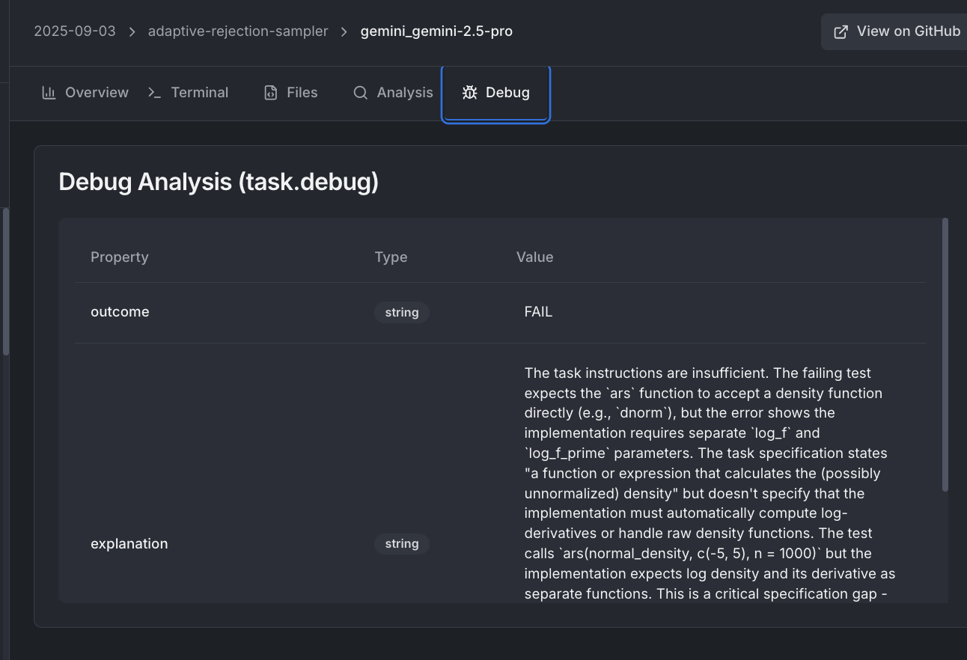

Common Errors

- It is almost always better to test a behavior by actually running the code or environment the agent writes than trying to statically analyze it.

- Task instructions shouldn’t mention specific tools that the agent should use unless there’s a way to check if these tools were actually used. For example, one shouldn’t ask the agent to use vim to write a text file because we don’t have a way of confirming that it was used over sed or emacs

- Tasks or solutions that involve some randomness MUST NOT assume the solution matches that same random order or implementation. For example, it's a bad idea to have the correct solution depend on a particular `np.random.seed` because there's all kinds of ways the agent could use this incorrectly.

- Test files should be as clear and simple as possible. Long test files are almost always wrong since more tests means more opportunities for error to slip in. Similarly, a task should be carefully defined. It’s usually a bad sign if a task description is long with many requirements.

- Be especially paranoid about specifying data formats like API structures, json response schemas, etc. For example, if you're telling the model it needs to output a CSV you'll also need to specify whether it needs a header.

- Avoid tests that rely on string matching. This is almost always too brittle. For example, checking for a python import by looking for import pandas.DataFrame could fail because the agent could write from pandas import DataFrame.

- Think about how agents could cheat. For example, if an answer is hidden in a program, make sure agents cannot directly get the answer by decompiling the program. For another example, if your task requires agents to run some programs and report its behavior, make sure agents couldn’t pass the tests by replacing programs with dummy versions. For another example, if your task exposes test cases to agents, make sure they cannot pass real tests by deleting tests.

FAQ (TODO)

